# Operational Concept Description (OCD)

**Healthy Kids Zone Survey App**

**Team 14**

|  |  |  |
| --- | --- | --- |
| **Name** | **Primary Role** | **Contact Email** |
| Joseph Martinez | Client | JMartinez2@chc-inc.org |
| Carson Malcoln | Client | MCarson@chc-inc.org |
| Yang Wang | Project Manager  Life Cycle Planner | wang195@usc.edu |
| Chad Honkofsky | IIV&V/QFP | honkofsk@usc.edu |
| Xu Zhang | Builder (Front-end Designer) | zhangxu@usc.edu |
| Chenglu Wang | Tester | wang358@usc.edu |
| Junjun Ji | Builder (Mobile Designer) | junjunji@usc.edu |
| Ye Tao | Builder (Back-end Designer) | taoye@usc.edu |

# Version History

| Date | Author | Version | Changes made | Rationale |
| --- | --- | --- | --- | --- |
| 10/12/2013 | Xu Zhang | 1.0 | * Original for CSCI577a; Tailored from ICSM OCD Template | * To fit CSCI577a VC Package |
| 10/15/2013 | Xu Zhang | 2.0 | * System Transformation | * To fit CSCI577a FC Package |
| 10/16/2013 | Xu Zhang | 2.1 | * Benefit Chain Diagram, Level of Goals | * To fit CSCI577a FC Package |
| 10/17/2013 | Xu Zhang | 2.2 | * Edit diagrams after review | * To fit CSCI577a FC Package |
| 10/21/2013 | Xu Zhang | 2.3 | * Edit diagrams after FCR-ARB | * Incorporate Comments from FCR-ARB |
| 11/21/2013 | Xu Zhang | 3.1 | * Edit diagrams for DCR-ARB | * To fit CSCI577a DC Package |
| 11/27/2013 | Xu Zhang | 3.2 | * Edit system boundary and element relationship diagram after discussion | * Identify internal and external software infrastructure in two diagrams |
| 12/01/2013 | Xu Zhang | 3.3 | * Edit benefit chain diagram and business workflow after discussion | * Change initiatives in benefit chain diagram; add some operations in business workflow diagram |
| 12/09/2013 | Xu Zhang | 3.4 | * Clarify what client is. | * To fit DCR-ARB |
| 02/08/2014 | Xu Zhang | 4.0 | * Re-assess the proposed system and modify the rearranged roles of team members. | * To fit RDCR-ARB |

# Table of Contents

Operational Concept Description (OCD) i

Version History ii

Table of Contents iii

Table of Tables iv

Table of Figures v

1. Introduction 1

2. Shared Vision 2

2.1 Overview of the system 2

2.2 System Boundary and Environment 3

3. System Transformation 5

3.1 Information on Current System 5

3.2 System Objectives, Constraints and Priorities 5

3.3 Proposed New Operational Concept 7

3.4 Organizational and Operational Implications 10

# Table of Tables

Table 1: The Program Model of HKZ Survey App 2

Table 2: Capability Goals 5

Table 3: Level of Service Goals 6

# Table of Figures

Figure 1: System Boundary and Environment Diagram 3

Figure 2: Benefit Chain Diagram 4

Figure 3: Element Relationship Diagram 7

Figure 4: Business Workflow Diagram 8

### 1. Introduction

* **Purpose:**

This document provides in detail the shared visions and goals of the Healthy Kid Zone (HKZ) Survey App through negotiation and analysis of the requirements and features the clients have proposed. The clients are Malcolm Carson and Joseph Martinez who represent the Community Health Councils (CHC); the users are survey takers; the developers are Team 14 of CSCI577A/B 2013 Fall semester.

* **Status:**

At completion of the foundation phase of the Incremental Commitment Spiral Model (ICSM), version 4.0 re-assesses all sections of Operational Concept Document defined in IOC Package based on proposed new system. This version captures all sections of the Operational Concept Document in support of the Initial Operational Capability Package.

### 2. Shared Vision

#### 2.1 Overview of the system

Table : The Program Model of HKZ Survey App

|  |  |  |  |
| --- | --- | --- | --- |
| **Assumptions:**   * Community is willingand able to adopt electronic surveys. * Survey will improve the health of community well-being. | | | |
| **Stakeholders** | **Initiatives** | **Value Propositions** | **Beneficiaries** |
| * Project client * Users * Developers * Maintainer | * Develop new HKZ Survey App * Promote the app * Provide training for taking survey process * Develop partnership with agencies such as LAUSD or LADOT | * Save time and money(print survey docs) for all to do the survey * Increase geospatial accuracy of collected data around schools * Increase survey participation * Increase efficiency in fixing environment problems performing to specific locations * Increase survey adaption by other agencies | * Residents * Local schools * External agencies |

#### 2.2 System Boundary and Environment

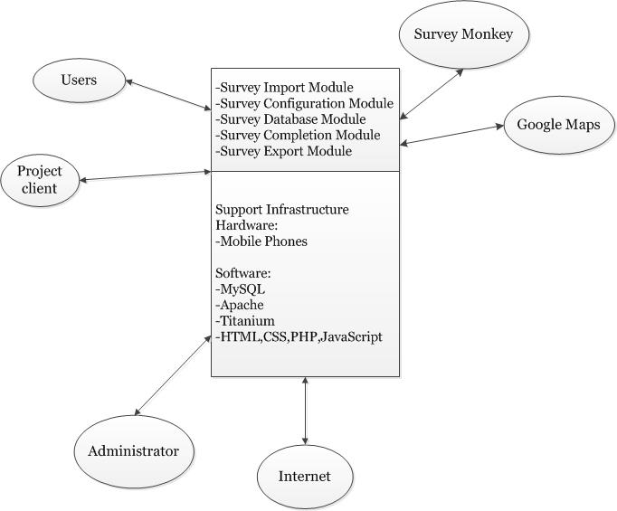

Figure : System Boundary and Environment Diagram

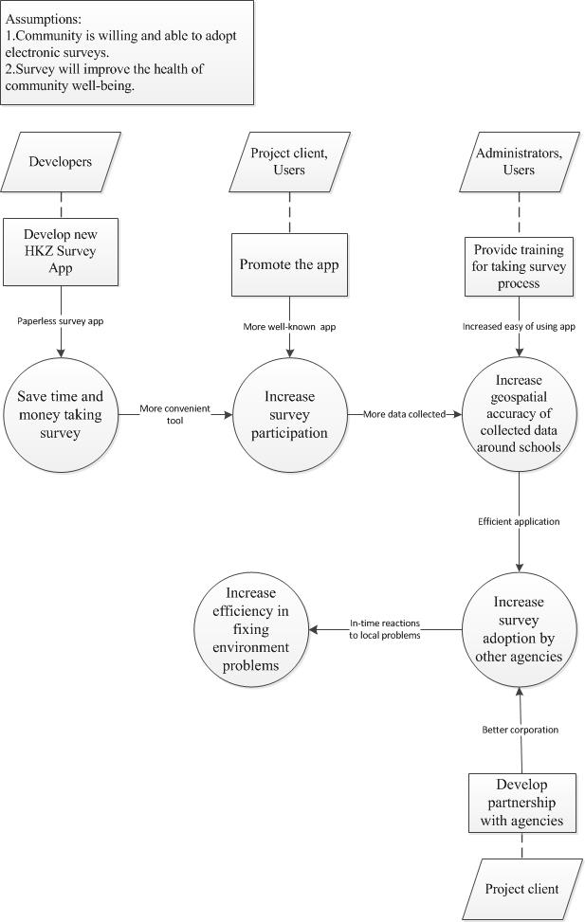

Figure : Benefit Chain Diagram

### 3. System Transformation

#### 3.1 Information on Current System

This document captures the Healthy Kids Zone Survey application at inception.

#### 3.2 System Objectives, Constraints and Priorities

##### 3.2.1 Capability Goals

Table 2: Capability Goals

|  |  |
| --- | --- |
| **Capability Goals** | **Priority Level** |
| **OC-1** Survey Import: The system allows administrators to import surveys created at the Survey Monkey website**.** | Must have |
| **OC-2** Survey Configuration: The system allows administrators to manage (create/modify/delete) paths or schools and the associations between paths, schools and surveys. | Must have |
| **OC-3** Survey Database: The system allows for the storage of survey definitions and survey results. | Must have |
| **OC-4** Survey Completion**:** The android app allows users to complete a survey and submit results. | Must have |
| **OC-5** Survey Export: The system can export survey results in comma separated value (csv) format. | Must have |

##### 3.2.2 Level of Service Goals

Table : Level of Service Goals

|  |  |  |
| --- | --- | --- |
| **Level of Service Goals** | **Priority Level** | **Referred WinWin Agreements** |
| **Response Time:** the app response time should be less than or equal to 2 seconds | Must have | WC_2724,WC_2710,WC_2707, WC_2704 |
| **Concurrent users:** can support a maximum of 200 users | Must have | WC_2723 |

##### 3.2.3 Organizational Goals

* **OG-1:** Save time and money (e.g.: print surveys) for CHC to design survey on paper.
* **OG-2:** Improve efficiency in updating local community plans via collecting geospatial data from residents
* **OG-3:** Increase efficiency in fixing environment problems via geospatial data
* **OG-4:** Improve survey methods of other agencies such as LAUSD and LADOT by adoption of CHC survey methods
* **OG-5:** Increase in addressing community safety via improving willingness to take surveys

##### 3.2.4 Constraints

* **CO-1:** Required Platform: Android mobile platform for HKZ survey completion and submission
* **CO-2:** Budget: $200
* **CO-3:** Required Maps: Google Maps
* **CO**-4**:** Required Survey Creation Tool: Survey Monkey

#### 3.3 Proposed New Operational Concept

##### 3.3.1 Element Relationship Diagram

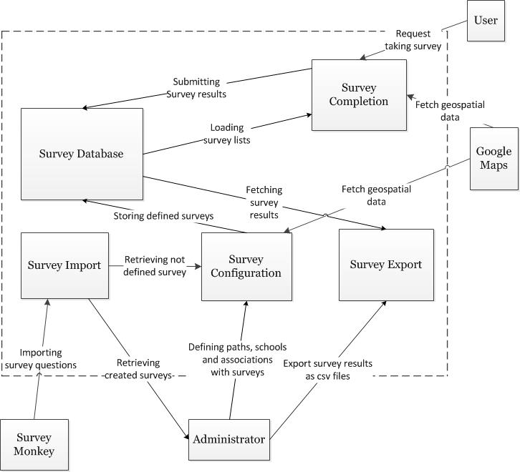

Figure : Element Relationship Diagram

##### 3.3.2 Business Workflows

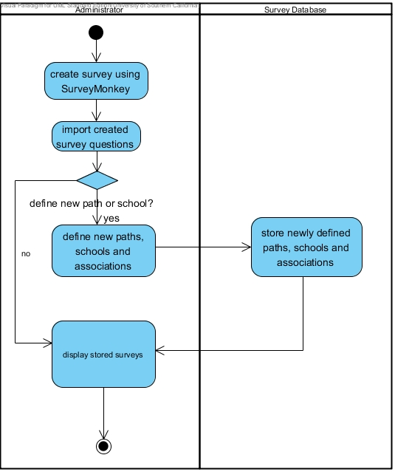

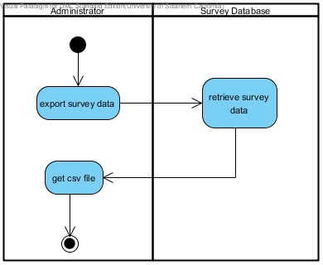

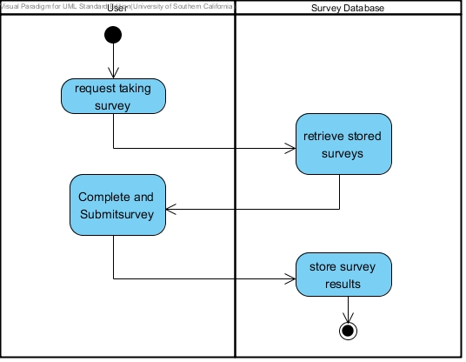

Figure : Business Workflow Diagram

#### 

#### 3.4 Organizational and Operational Implications

##### 3.4.1 Organizational Transformations

* The need for new maintainer to learn about MySQL, PHP, HTML5, CSS, and JavaScript to maintain the system
* The elimination of CHC interns doing data entry of survey data

##### 3.4.2 Operational Transformations

* The elimination of paper surveys by allowing surveyors to complete electronically
* Survey data entered directly into database by electronic submission eliminates data entry transcription errors or processing illegible responses
* Analyzing geospatial data quickly through internet rather than manual computation
* The improved chance for external agencies, LAUSD or LADOT, to adopt the HKZ system
* The elimination of CHC conducting paper survey training sessions